**LEBANESE AMERICAN UNIVERSITY**

**USAID – HIGHER EDUCATION SCHOLARSHIP PROGRAM**

**HES - Volunteering Program Verification Form**

This form is to be used to document volunteering hours. If a student volunteers for multiple organizations, a separate form must be used for each organization. **This form must be turned in by the 28th of each month, the latest.**

I certify that the scholar Gaelle Nemer completed a total of 22 hours of service at InnovaThrive.

The hours were completed hours as per the below:

Hours # 10 (date) _2/12 – 6/12_ (initials of supervisor) __A.K.___

Hours # 5 (date) _9/12 – 13/12_ (initials of supervisor) __A.K.___

Hours # 5 date) _16/12 – 20/12 (initials of supervisor) __A.K.___

Hours # 2 date) _23/12 - 27/12 (initials of supervisor) __A.K.___

Brief description of the activities the scholar performed or participated in:

I worked in multiple roles, including as a moderator and content creator. As a moderator, I reviewed written research papers on topics such as Gamification in Education and AI in Cybersecurity. My tasks involved adjusting AI-related percentages, paraphrasing content, refining templates, and ensuring that references adhered to APA guidelines.  
  
In my role as a content creator, I developed an interactive quiz focused on business applications, which was designed to engage users on a social media platform. This work required creating engaging and informative content to showcase practical insights and applications relevant to the business world, aiming to educate and captivate the social media audience.

Written feedback about the scholar’s performance:

Gaelle displayed strong multitasking and content creation skills, effectively moderating research papers and developing engaging, business-focused interactive quizzes.

Please rate the overall performance of the scholar at your organization:

|  |  |  |  |
| --- | --- | --- | --- |
|  | Mastery (5) | Proficient (3) | Emerging (1) |
| **Problem solver** | X |  |  |
| **Engaged & Committed** | X |  |  |
| **Open-minded & multicultural** | X |  |  |

Signature

& stamp

__________________________

_

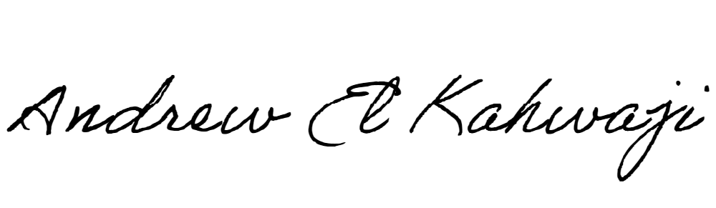

Printed Name _Andrew El Kahwaji_

Date __26/12/2024___

Email __andrew.lifesculptor.coo@gmail.com __

Phone __+961 71 914 378__